Hexapod Robot with Articulated Body

**A.V. Panchenko1, V.E. Pavlovsky2, D.L. Sholomov3**

1,2KIAM RAS, Moscow, Russia

3ISA FRC CSC RAS, Moscow, Russia

*E-mail: 1* [*panchenkoAV@vap.ru*](mailto:panchenkoAV@vap.ru)

*E-mail: 2* [*vlpavl@mail.ru*](mailto:vlpavl@mail.ru)

*E-mail: 3* [*sholomov@list.ru*](mailto:sholomov@list.ru)

**Abstract**

The paper describes kinematic control for hexapod robot with three segment articulated body. Forward and inverse kinematics for articulated body described. Static stability studied in case of climbing so called cliff obstacle. Conditions for static stability during climbing sequence provided.

**Keywords:** Multi legged robot, obstacle climbing, articulated body.

INTRODUCTION

Study of walking machines is rather old question. Starting in

Ancient China [1] primitive mechanical designs and ending with state of the art reinforcement learning [2] and model predictive control [3] approaches. Multilleged walking robots are very complicated systems in terms of control and planning due to significant number of degrees of freedom (d.o.f.) and actuators, complexity of the environment and etc. Nowadays the most complex and robust walking machines are made by Boston Dynamics company[4]. Its robots are capable of working in human environment and outdoors. The basis of their solution is model predictive control and non-linear optimization. Their robots are based on the kinematics of mammals - dogs or horses. The kinematics of hexapod robots in turn is based on insects and spiders.

The main idea of the article – to study robot with articulated body, that differes from conventional mainstream hexapods have rigid body with legs attached symmetrically. Conventional single body arrangement has its limitations but still can be surprisingly agile and overcomes complex obstacles as it was demonstrated in [5, 6]. Introducing additional degrees of freedom – making multiple rigid segments to be a body instead of one rigid body segment increases robot’s geometric patency. On the other hand, there is a trade off– the complexity of control will increase along with number of d.o.f. and actuators but the robot will climb up higher obstacles or do maneuvers that robots with rigid body are not capable of. For example, go through narrow passage, sharp ditch and windrows, climbing up cliffs.

ROBOT KINEMATICS

Let us consider robot depicted on figure figure 1. It has six so-called insectomorphic legs, i.e. insect-like leg kinematics. Each leg has three degrees of freedom. Body consists of three rigid segments connected with hinges to each other. Body that consists of several segments connected to each other with controllable joints and can change its geometry is called articulated.

The total number of degrees of freedom (d.o.f.) for specified robot is 26:

* 3 d.o.f. for each leg, i.e. 18 d.o.f. for all legs
* 2 d.o.f. for body segments
* 6 d.o.f. for the whole system as one single body

Overall it is 26 d.o.f. and 20 of them can be controlled with an actuators installed in corresponding rotational joints. Leg kinematics is well known and was already studied in all details.

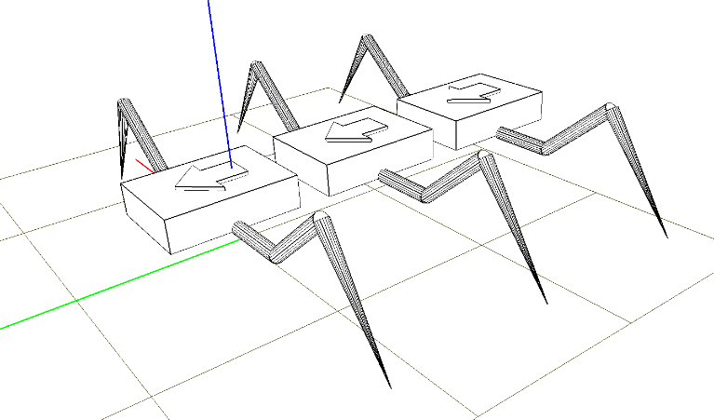

Figure . Hexapod robot with articulated body

CLIFF OBSTACLE

Cliff obstacle consists of three planes two of which are horizontal and one is vertical as depicted on figure 2.

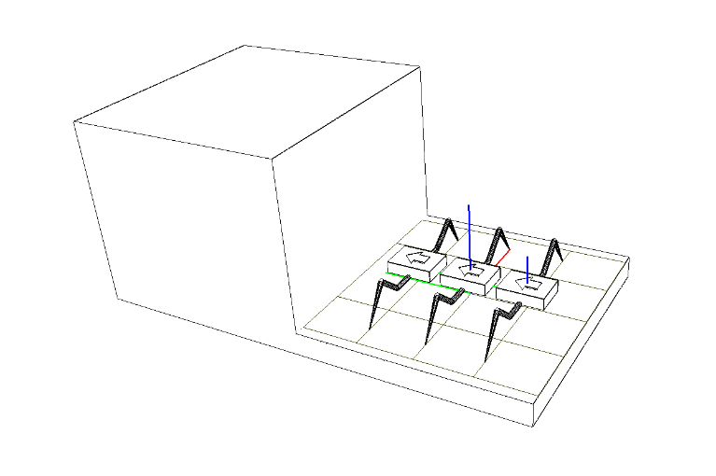

Figure . Cliff obstacle

The distance between two horizontal planes is equal to *H*. The ratio between robot’s body length and cliff’s height is equal to 1.0. Robot starts from the lower horizontal plane and his goal is to climb up the higher horizontal plane using only the Coulomb friction.

To overcome cliff obstacle robot moves using so-called gallop gait when a pair of symmetrical legs from left and right sides of the robot are in transition state and the others are in support state, i.e. in every moment of time there are four legs in contact with obstacle. Body kinematics will be considered in next section.

BODY KINEMATICS

Robot’s body consists of three equal rigid segments connected to each other with rotational joints with axes aligned in lateral direction of the body. Each segment has a pair of legs connected. Additional joints in the robots body allow to bend body and follow the surface shape and shift legs mounting points towards to supporting surface.

The following procedure is defined to calculated body joint angles. Initial and goal poses for middle segment are connected with a cubic spline curve, which represents target trajectory for middle segment. If segments and their trajectory are known then the taks is solved through simple linear approximation.

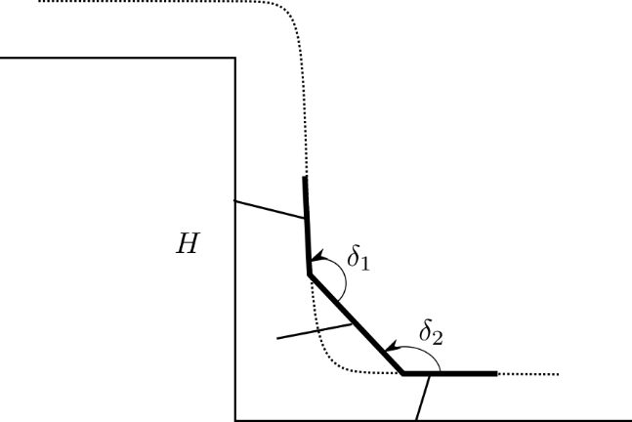

Figure . Articulated body kinematics

To keep the contact points on the goal trajectory all joints should act in a coordinated way. At every moment of time all joint coordinates must be updated to keep the end effector at the goal position. Additional mobility inside the robots body should be taken into account because all legs are connected to the different segments. Target point for *i-*th leg is given in global reference frame. To obtain leg joint angles the inverse kinematic equations are used, point must be translated into leg’s reference frame. To manage all relative coordinate transformations of shifts and rotations between body segments, legs and joints, homogenous coordinates are used. Calculation of all coordinate transformation for each leg at every moment of time can be easily done automatically through well-known kinematics of a robot.

The main differences of articulated body from single segment body are:

* Higher ability to overcome obstacles – segments follow the surface;
* Articulated body is able to shift mounting points of its legs – service region is not constant, i.e. in some conditions robot can reach contact surface and put legs on it;
* Center of gravity is shifted in a wider range with all else parameters being equal – critical parameter in static stability preservation in extreme conditions.

STATIC STABILITY

The system is stable when sums of all external forces and all momentums are equal to zero.

|  |  |  |
| --- | --- | --- |
|  |  | (1) |

The following configurations of supporting legs displacement should be studied for static stability:

* All legs on some horizontal plane. This case is already well studied in ;
* Front legs lean against the vertical plane and rear legs stand on the lower horizontal plane. Let us numerate this configuration as Number One.
* Front legs are placed at the upper horizontal plane, while the rear legs stand on the vertical plane. Let us numerate this configuration as Number Two.
* All legs stand on the upper horizontal plane – this case is similar to the initial one.

Considering the robot as a slow moving system at every moment of time let us find necessary conditions for static stability.

Reference frame *Oxyz* is defined as depicted on the figure 4.

**Equations for first configuration**

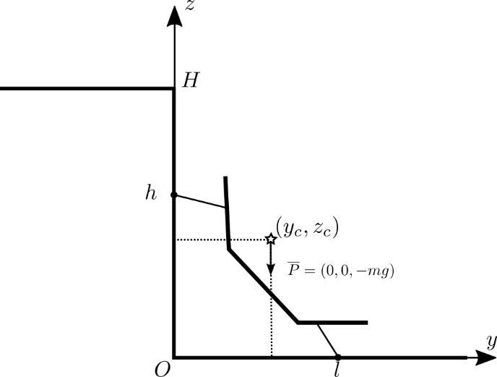

Figure . First static configuration

Contact points of the legs for first configuration are as follows:

|  |  |  |
| --- | --- | --- |
|  |  | (2) |

There is a reactions acting on the robot leg at each contact point:

|  |  |  |
| --- | --- | --- |
|  |  | (3) |

The and vectors have the following coordinates:

|  |  |  |
| --- | --- | --- |
|  |  | (4) |
|  |  |  |

The center of gravity has coordinates:

|  |  |  |
| --- | --- | --- |
|  |  | (5) |

The gravity force acts on the center of gravity of the robot:

|  |  |  |
| --- | --- | --- |
|  |  | (6) |

The equations of static stability for first configuration are as follows:

|  |  |  |
| --- | --- | --- |
|  |  | (7) |

The total number of equation is six. The number of unknown variables is twelve. Let us assume that the friction forces are modelled with Coulomb mathematical model:

, where is coefficient of Coulomb friction for *i*-th leg in *j*-th direction and .

After substitution of the Coulomb friction model, the equations (7) will transform into the following system:

|  |  |  |
| --- | --- | --- |
|  |  | (8) |

The number of unknowns variables remains the same, and besides . Let us introduce additional assumptions that the left and the right side of the robot are loaded equally and coefficients of friction are the same between left and right legs:

|  |  |  |
| --- | --- | --- |
|  |  | (9) |

Finally, the system of three equations and four variables obtained:

|  |  |  |
| --- | --- | --- |
|  |  | (10) |

Number of unknowns is still greater than number of equations. One more assumption must be introduced:

|  |  |  |
| --- | --- | --- |
|  |  | (11) |

Finally, the system of three equations and three unknowns obtained:

|  |  |  |
| --- | --- | --- |
|  |  | (12) |

Let us find unknown reactions and . From first and second equations of (12) follows:

|  |  |  |
| --- | --- | --- |
|  |  | (13) |

After substituting (13) to the third equation of (12) we have quadratic equation relative to :

|  |  |  |
| --- | --- | --- |
|  |  | (14) |

There are two solutions for quadratic equation (14). To make robot able to climb up the cliff without any hooks and adhesive forces the friction coefficient must satisfy the condition:

|  |  |  |
| --- | --- | --- |
|  |  | (15) |

It is easy to show that only the following solution fulfills the requirements of the accounted configuration:

|  |  |  |
| --- | --- | --- |
|  |  | (16) |

The solution (16) is always greater than zero. Let us study when the condition is fulfilled for . To study this three dimensional parametric space the following dimensionless parameters will be introduced.

**Dimensionless parameters**

It is easy to see that the expression (16) for depends on and parameters that are measured in meters – they all have the same physical dimension. Let us use this circumstance and define the following dimensionless parameters:

|  |  |  |
| --- | --- | --- |
|  |  | (17) |

After substitution of (17) into the expanded and simplified expression (16) we get the following solution depicted on figure 5.

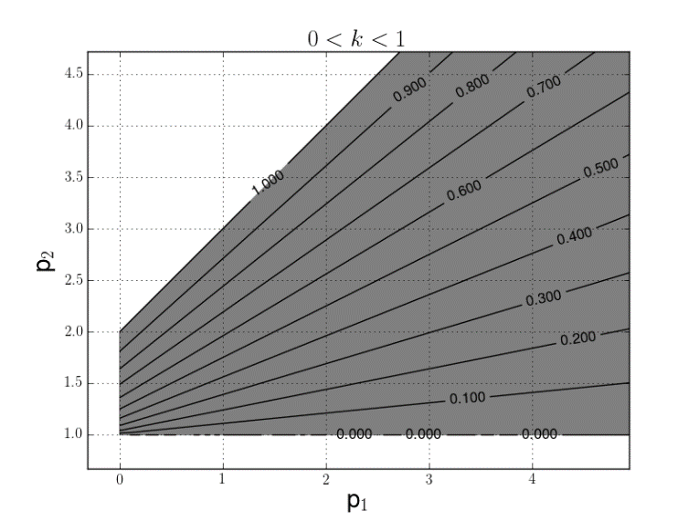

Figure . Solution for first configuration with labeled levels for value of *k* coefficient

From figure 5 it becomes clear that if there is lack of friction in contact points the robot should:

* move its center of gravity closer to the rear legs;
* choose contact points higher on the vertical plane for front legs;
* choose contact points closer to vertical plane for rear legs.

**Equations for second configuration**

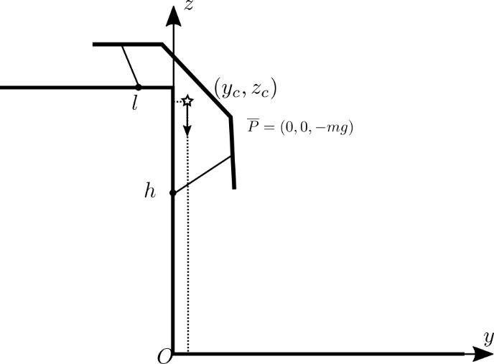

Figure . Second static configuration

Leg contact points for the second configuration are:

|  |  |  |
| --- | --- | --- |
|  |  | (18) |

Similarly, for the second configuration we get the following system of three equations:

|  |  |  |
| --- | --- | --- |
|  |  | (19) |

There are two possible solutions for from (19). It is easy to see that this time can change its sign because of center of gravity transition above the upper edge of the cliff. Only the following solution for *k* stays greater than zero for every sign of :

|  |  |  |
| --- | --- | --- |
|  |  | (20) |

Let us find solution of inequality using the following dimensionless parameters:

|  |  |  |
| --- | --- | --- |
|  |  | (21) |

Parts of the solution for inequality (15) in dimensionless space for second configuration are depicted on figure 7 and figure 8.

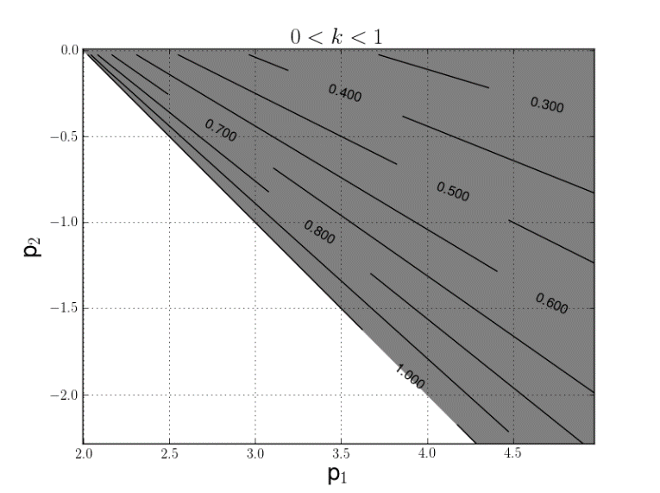

Figure . Solution for second configuration when , with labeled levels for *k* coefficient

From figure (7) it can be shown that for case when to reduce the value of the robot should:

* keep its center of gravity far from front legs;
* keep rear legs as low as possible;
* keep front legs closer to cliff edge.

From figure (8) it can be shown that for case when to reduce the value of the robot should:

* keep its center of gravity closer to front legs;
* keep rear legs as low as possible;
* keep front legs closer to cliff edge.

We have considered the second configuration in assumption that . Let us see what happens when center of gravity is right above the cliffs edge in second configuration.

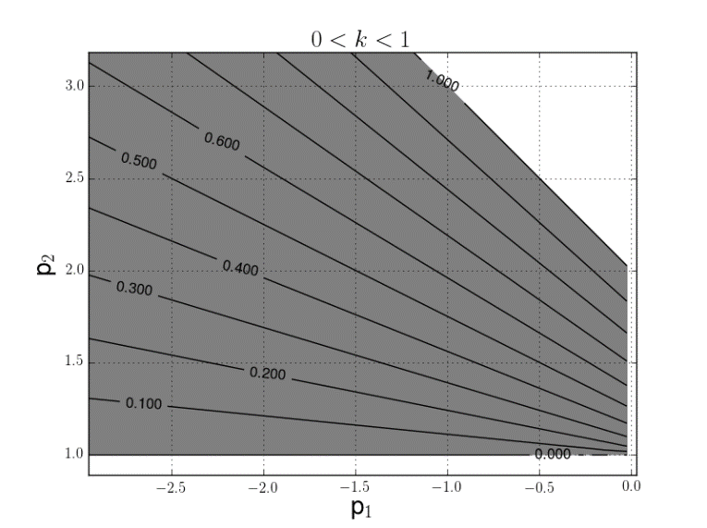

Figure . Solution for second configuration when , with labeled levels for *k* coefficient

**Second configuration. equals to zero**

If the = 0 the equations of static stability equations (19) will transform into the following system:

|  |  |  |
| --- | --- | --- |
|  |  | (22) |

There is only one solution for for system (22):

|  |  |  |
| --- | --- | --- |
|  |  | (23) |

Due to condition , the expression for is always greater than zero. From the other side, the requirement is equivalent to the following inequality:

|  |  |  |
| --- | --- | --- |
|  |  | (24) |

Inequality (27) means that to provide stable configuration in case when the contact points should be chosen in a way, that the front legs should be closer to cliff edge than the rear legs.

Reactions and will have the following expressions:

|  |  |  |
| --- | --- | --- |
|  |  | (25) |

CONCLUSION

The analysis of the robot configurations in different poses on the cliff proved that stable quasi static motion is possible for all steps, i.e. the robot is capable of climbing the cliff with static stability preservation using only Coulomb friction forces.

**ACKNOWLEDGEMENTS**

The research work is supported by the Russian Foundation for Basic Research. The unique project number is 16‑31‑00524 mol_a.

**REFERENCES**

1. Yan, H. S. (2005). Historical trace and restoration of ancient Chinese walking machines. Journal of the Chinese Society of Mechanical Engineers, 26(1), 133-137.
2. Peng, X. B., Berseth, G., Yin, K., & Van De Panne, M. (2017). Deeploco: Dynamic locomotion skills using hierarchical deep reinforcement learning. ACM Transactions on Graphics (TOG), 36(4), 41.
3. Diedam, H., Dimitrov, D., Wieber, P. B., Mombaur, K., & Diehl, M. (2008, September). Online walking gait generation with adaptive foot positioning through linear model predictive control. In Intelligent Robots and Systems, 2008. IROS 2008. IEEE/RSJ International Conference on (pp. 1121-1126). IEEE.
4. Raibert, M., Blankespoor, K., Nelson, G., & Playter, R. (2008). Bigdog, the rough-terrain quadruped robot. IFAC Proceedings Volumes, 41(2), 10822-10825.
5. Golubev, Y. F., & Koryanov, V. V. (2008). A control for an insectomorphic robot in climbing to the top of a vertical corner and in moving on a step ladder. Journal of Computer and Systems Sciences International, 47(1), 139-148.
6. Golubev, Y. F., & Koryanov, V. V. (2009). Motion control for an insectomorphic robot on a movable ball. Journal of Computer and Systems Sciences International, 48(5), 801.
7. A. V. Panchenko, I. A. Orlov and V. E. Pavlovsky, Control algorithm for walking robot with mosaic body, in ASSISTIVE ROBOTICS: Proceedings of the 18th International Conference on CLAWAR 2015, (Hangzhou, China, 2016).